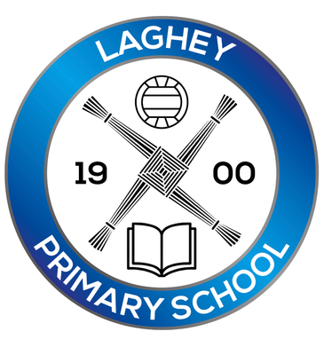

Laghey PS Eco-Council Job Description

As the Eco-Council, it will be our job to work with the other children in our school to make it a more environmentally friendly place. As part of this you will need to:
- Share ideas in regular Eco-Council meetings
- Carry out an environmental review to measure our school’s performance against the nine Eco topics.
- Help create an action plan for how we can make Laghey PS eco-friendlier over the coming year.
- Speak to other members of the school community, which might include parents, governors, pupils, and teachers.
- Bring ideas from your class to the meetings and feedback what we have discussed.
- Be willing to speak and take part in school assemblies.
- Help write articles for the newsletter/ school website.
- Take part in litter picks and environmental activities and initiatives.
- Help the school be more energy effective during its daily running e.g. switching off lights, closing doors, weeding the vegetable patch, picking up litter
- Help the school maintain the Green Flag status.

